A comparison of ChatGPT to other pre-trained language models, such as BERT and GPT-2
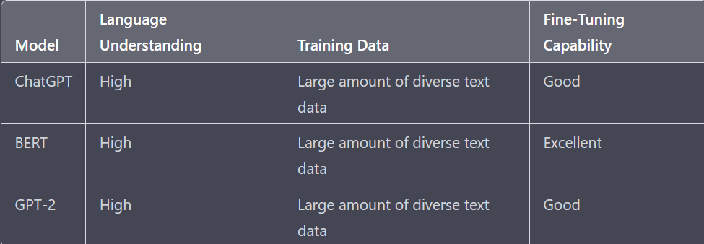
ChatGPT, BERT and GPT-2 are all pre-trained language models developed by OpenAI, all with high language understanding and trained on large amounts of diverse text data. ChatGPT is best for conversational tasks such as chatbot development and language translation and has a good fine-tuning capability. BERT is good for understanding the meaning of the text and is popular for tasks such as question answering and sentiment analysis. It has an excellent fine-tuning capability. GPT-2 is more focused on text generation and has a good fine-tuning capability but not as good as BERT.

BERT, GPT-2, and ChatGPT are pre-trained language models developed by OpenAI. ChatGPT is best for conversational tasks, BERT for understanding text, and GPT-2 for text generation. Additionally, BERT has the best fine-tuning capability. All of them have a high level of language understanding and have been trained on large amounts of diverse text data.

In summary, ChatGPT, BERT, and GPT-2 are pre-trained models with high language understanding and are trained on large amounts of diverse text data. ChatGPT is best for conversation, BERT for understanding text, and GPT-2 for text generation. BERT has the best fine-tuning capability.

